9/4/2026
Seaney Maseko ST10493031

PROGRAMMING 2B PROG6212

Contents
Section A ERD 2
Section B: API Endpoint Plan 5
Section C: SQL Database Script 11
GitHub and Reference 21

Section A ERD
Entity
Users
- Stores each user account and links the user to a role such as Organiser or Participant.
Roles
- Lookup table for the two system roles: Organiser and Participant.
Events
- Stores event information including name, description, date, location, distance and event type.
Categories
- Stores age-based or distance-based categories used for event participation.
EventCategories
- Junction table connecting Events and Categories in a many-to-many relationship.
Enrolments
- Records Participants entering Events and selecting a Category.
Results
- Stores a Participant result after an event, including finish time and finishing position.

ERD
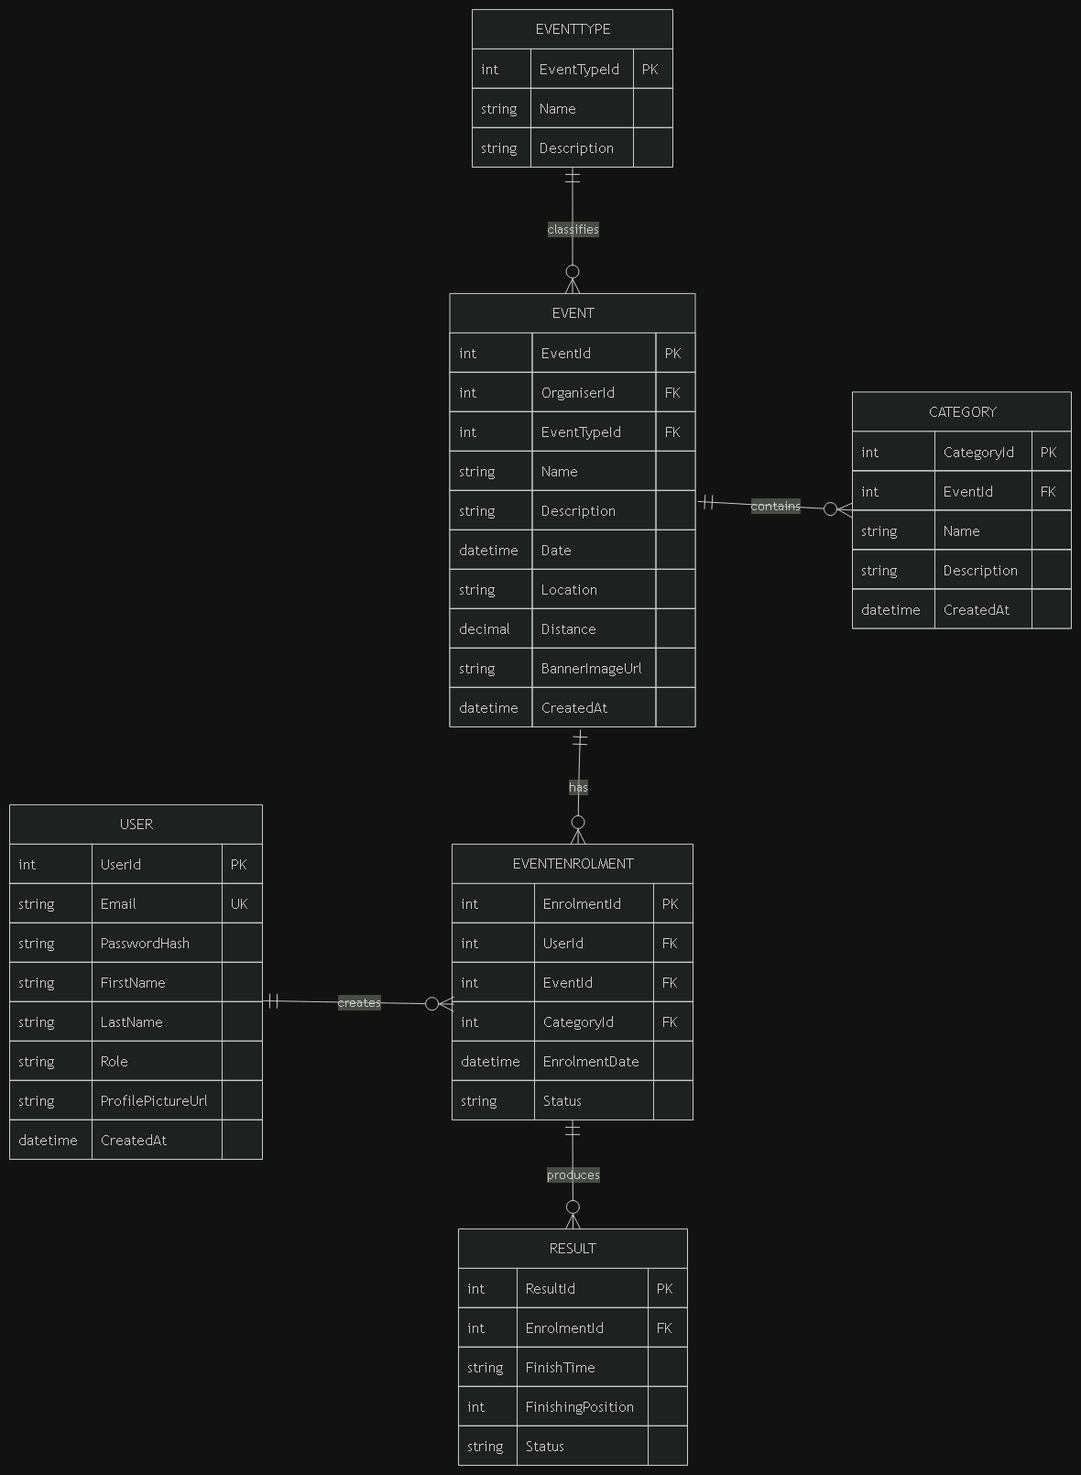 (draw.io)

Relationships
- Users - Roles: Each user has one role. A role can have many users.
- Users - Enrolments: One user (participant) can have many enrolments. Each enrolment belongs to one user.
- Users - Events: One user (organiser) can create many events. Each event has one organiser.
- Events - Enrolments: One event can have many enrolments. Each enrolment is for one event.
- Events - Categories: Connected through a middle table (EventCategories) because events and categories have a many-to-many relationship.
- Enrolments Results: Each enrolment has zero or one result. Each result belongs to one enrolment.
- Enrolments - Categories: Each enrolment picks one category. A category can be used by many enrolments.

Primary and Foreign Key Constraint Summary
- Users: PK = UserId; FK = RoleId – references Roles.RoleId.
- Roles: PK = RoleId; no foreign keys.
- Events: PK = EventId; FK = OrganiserId – references Users.UserId.
- Categories: PK = CategoryId; no foreign keys.
- EventCategories: PK = EventCategoryId; FKs = EventId - Events.EventId and CategoryId - Categories.CategoryId.
- Enrolments: PK = EnrolmentId; FKs = ParticipantId - Users.UserId, EventId - Events.EventId, and CategoryId - Categories.CategoryId.
- Results: PK =ResultId; FK =EnrolmentId - Enrolments.EnrolmentId (with a unique constraint to maintain the One-to-One cardinality).

Section B: API Endpoint Plan
HTTP Method | Route | Description | Role Required | Request Body | Expected Response
POST | /api/auth/register | Register a new user account with role selection | None (Public) | { email, password, firstName, lastName, role } | 201 Created - user details 400 Bad Request - validation errors 409 Conflict - email exists
POST | /api/auth/login | Authenticate user and create session | None (Public) | { email, password } | 200 OK - { message, role, userId } 401 Unauthorized - invalid credentials
POST | /api/auth/logout | End current user session | Any (Logged in) | None | 200 OK - logged out successfully
GET | /api/users/profile | Get current user's profile information | Any (Logged in) | None | 200 OK - user details 401 Unauthorized
PUT | /api/users/profile | Update current user's profile | Any (Logged in) | { firstName, lastName, profilePictureUrl } | 200 OK - updated user 400 Bad Request - validation errors 401 Unauthorized
GET | /api/events | Get all events with optional filters | None (Public) | None | 200 OK - list of events
GET | /api/events/{id} | Get specific event details | None (Public) | None | 200 OK - event details 404 Not Found
POST | /api/events | Create a new event | Organiser | { name, description, date, location, distance, eventTypeId, bannerImageUrl } | 201 Created - new event 400 Bad Request 401 Unauthorized
PUT | /api/events/{id} | Update an existing event | Organiser | { name, description, date, location, distance, eventTypeId, bannerImageUrl } | 200 OK - updated event 400 Bad Request 401 Unauthorized 404 Not Found
DELETE | /api/events/{id} | Delete an event | Organiser | None | 204 No Content 401 Unauthorized 404 Not Found
GET | /api/events/{eventId}/categories | Get all categories for an event | None (Public) | None | 200 OK - list of categories 404 Not Found
POST | /api/events/{eventId}/categories | Create a new category for an event | Organiser | { name, description } | 201 Created - new category 400 Bad Request 401 Unauthorized
PUT | /api/categories/{id} | Update a category | Organiser | { name, description } | 200 OK - updated category 401 Unauthorized 404 Not Found
DELETE | /api/categories/{id} | Delete a category | Organiser | None | 204 No Content 401 Unauthorized 404 Not Found
GET | /api/events/{eventId}/enrolments | Get all enrolments for an event | Organiser | None | 200 OK - list of enrolments 401 Unauthorized 404 Not Found
POST | /api/events/{eventId}/enrol | Enrol a participant in an event | Participant | { categoryId } | 201 Created - enrolment details 400 Bad Request 401 Unauthorized 409 Conflict
GET | /api/users/enrolments | Get all enrolments for the current user | Participant | None | 200 OK - list of enrolments 401 Unauthorized
PUT | /api/enrolments/{id}/status | Update enrolment status | Organiser | { status } | 200 OK - updated enrolment 401 Unauthorized 404 Not Found
POST | /api/enrolments/{enrolmentId}/results | Capture result for a participant | Organiser | { finishTime, finishingPosition } | 201 Created - result details 400 Bad Request 401 Unauthorized
GET | /api/users/results | Get current user's race results | Participant | None | 200 OK - list of results 401 Unauthorized
GET | /api/events/{eventId}/results | Get all results for an event | Organiser | None | 200 OK - list of results 401 Unauthorized 404 Not Found
GET | /api/eventtypes | Get all event types (run/walk/cycle) | None (Public) | None | 200 OK - list of event types
POST | /api/events/{id}/banner | Upload event banner image | Organiser | multipart/form-data file | 200 OK - { bannerImageUrl } 401 Unauthorized 404 Not Found
PUT | /api/users/profile/picture | Upload profile picture | Any (Logged in) | multipart/form-data file | 200 OK - { profilePictureUrl } 401 Unauthorized
l

Section C: SQL Database Script
-- 1. CREATE DATABASE
CREATE DATABASE DBRaceDay;
GO
USE DBRaceDay;
GO
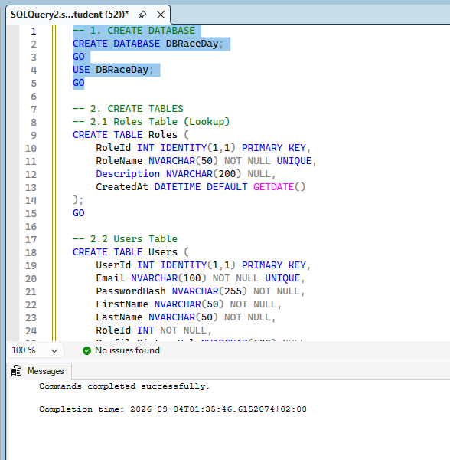
-- 2.1. Roles Table
CREATE TABLE Roles (
RoleId INT IDENTITY(1,1) PRIMARY KEY,
RoleName NVARCHAR(50) NOT NULL UNIQUE,
Description NVARCHAR(200) NULL,
CreatedAt DATETIME DEFAULT GETDATE()
);
GO

-- 2.2 Users Table
CREATE TABLE Users (
UserId INT IDENTITY(1,1) PRIMARY KEY,
Email NVARCHAR(100) NOT NULL UNIQUE,
PasswordHash NVARCHAR(255) NOT NULL,
FirstName NVARCHAR(50) NOT NULL,
LastName NVARCHAR(50) NOT NULL,
RoleId INT NOT NULL,
ProfilePictureUrl NVARCHAR(500) NULL,
CreatedAt DATETIME DEFAULT GETDATE(),
CONSTRAINT FK_Users_Roles FOREIGN KEY (RoleId) REFERENCES Roles(RoleId),
CONSTRAINT CHK_Users_Email CHECK (Email LIKE '%_@__%.__%')
);
GO

-- 2.3. EventType Table (NEW – matches ERD)
CREATE TABLE EventType (
EventTypeId INT IDENTITY(1,1) PRIMARY KEY,
TypeName NVARCHAR(20) NOT NULL UNIQUE CHECK (TypeName IN ('Run', 'Walk', 'Cycle')),
Description NVARCHAR(200) NULL,
CreatedAt DATETIME DEFAULT GETDATE()
);
GO

-- 2.4. Events Table
CREATE TABLE Events (
EventId INT IDENTITY(1,1) PRIMARY KEY,
OrganiserId INT NOT NULL,
EventTypeId INT NOT NULL, -- changed
Name NVARCHAR(100) NOT NULL,
Description NVARCHAR(500) NULL,
EventDate DATETIME NOT NULL,
Location NVARCHAR(200) NOT NULL,
Distance DECIMAL(8,2) NOT NULL,
BannerImageUrl NVARCHAR(500) NULL,
CreatedAt DATETIME DEFAULT GETDATE(),
CONSTRAINT FK_Events_Users FOREIGN KEY (OrganiserId) REFERENCES Users(UserId),
CONSTRAINT FK_Events_EventType FOREIGN KEY (EventTypeId) REFERENCES EventType(EventTypeId)
);
GO

-- 2.5. Categories Table
CREATE TABLE Categories (
CategoryId INT IDENTITY(1,1) PRIMARY KEY,
Name NVARCHAR(50) NOT NULL,
Description NVARCHAR(200) NULL,
CategoryType NVARCHAR(20) NOT NULL CHECK (CategoryType IN ('Age', 'Distance')),
CreatedAt DATETIME DEFAULT GETDATE()
);
GO
-- 2.6. EventCategories
CREATE TABLE EventCategories (
EventCategoryId INT IDENTITY(1,1) PRIMARY KEY,
EventId INT NOT NULL,
CategoryId INT NOT NULL,
CONSTRAINT FK_EventCategories_Events FOREIGN KEY (EventId) REFERENCES Events(EventId) ON DELETE CASCADE,
CONSTRAINT FK_EventCategories_Categories FOREIGN KEY (CategoryId) REFERENCES Categories(CategoryId) ON DELETE CASCADE,
CONSTRAINT UQ_EventCategories_EventCategory UNIQUE (EventId, CategoryId)
);
GO

-- 2.7. Enrolments Table
CREATE TABLE Enrolments (
EnrolmentId INT IDENTITY(1,1) PRIMARY KEY,
ParticipantId INT NOT NULL,
EventId INT NOT NULL,
CategoryId INT NOT NULL,
EnrolmentDate DATETIME DEFAULT GETDATE(),
Status NVARCHAR(20) NOT NULL DEFAULT 'Pending'
CHECK (Status IN ('Pending', 'Confirmed', 'Cancelled', 'Completed')),
CONSTRAINT FK_Enrolments_Users FOREIGN KEY (ParticipantId) REFERENCES Users(UserId),
CONSTRAINT FK_Enrolments_Events FOREIGN KEY (EventId) REFERENCES Events(EventId) ON DELETE CASCADE,
CONSTRAINT FK_Enrolments_Categories FOREIGN KEY (CategoryId) REFERENCES Categories(CategoryId),
CONSTRAINT UQ_Enrolments_ParticipantEvent UNIQUE (ParticipantId, EventId)
);
GO

-- 2.8. Results Table
CREATE TABLE Results (
ResultId INT IDENTITY(1,1) PRIMARY KEY,
EnrolmentId INT NOT NULL,
FinishTime TIME NOT NULL,
FinishingPosition INT NOT NULL,
Status NVARCHAR(20) NOT NULL DEFAULT 'Finished'
CHECK (Status IN ('DNS', 'DNF', 'Finished')),
CreatedAt DATETIME DEFAULT GETDATE(),
CONSTRAINT FK_Results_Enrolments FOREIGN KEY (EnrolmentId) REFERENCES Enrolments(EnrolmentId) ON DELETE CASCADE,
CONSTRAINT UQ_Results_Enrolment UNIQUE (EnrolmentId)
);
GO

-- Indexes for performance
CREATE INDEX IX_Users_RoleId ON Users(RoleId);
CREATE INDEX IX_Users_Email ON Users(Email);
CREATE INDEX IX_Events_OrganiserId ON Events(OrganiserId);
CREATE INDEX IX_Events_EventDate ON Events(EventDate);
CREATE INDEX IX_EventCategories_EventId ON EventCategories(EventId);
CREATE INDEX IX_EventCategories_CategoryId ON EventCategories(CategoryId);
CREATE INDEX IX_Enrolments_ParticipantId ON Enrolments(ParticipantId);
CREATE INDEX IX_Enrolments_EventId ON Enrolments(EventId);
CREATE INDEX IX_Enrolments_CategoryId ON Enrolments(CategoryId);
CREATE INDEX IX_Enrolments_Status ON Enrolments(Status);
CREATE INDEX IX_Results_EnrolmentId ON Results(EnrolmentId);
GO
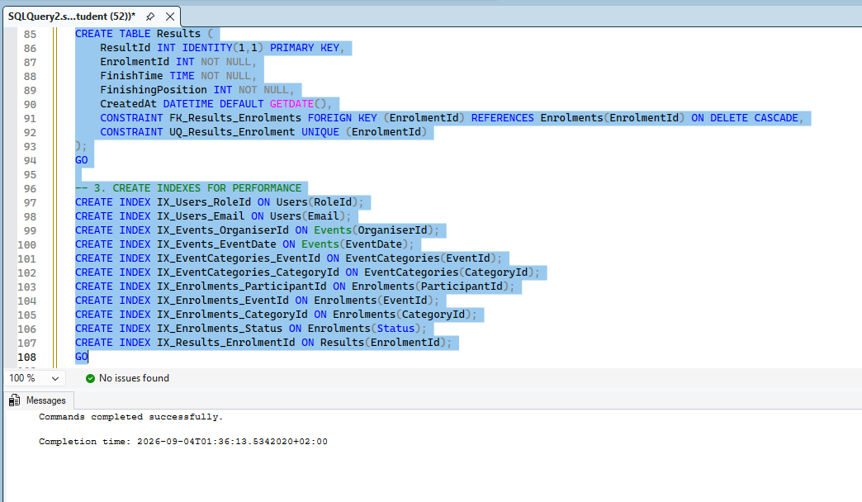
-- 4. SEED DATA
-- 1. Roles
INSERT INTO Roles (RoleName, Description) VALUES
('Organiser', 'Event organiser who can create and manage events, categories, and results'),
('Participant', 'Event participant who can browse events, enrol, and view results');
GO

-- 2. Event Types
INSERT INTO EventType (TypeName, Description) VALUES
('Run', 'Road running events including marathons, half-marathons, and fun runs'),
('Walk', 'Walking events including park runs and charity walks'),
('Cycle', 'Cycling events including road races and time trials');
GO

-- 4.3. Users (passwords hashed – placeholders)
INSERT INTO Users (Email, PasswordHash, FirstName, LastName, RoleId, ProfilePictureUrl) VALUES
('thabo.mokoena@raceday.co.za', 'hashed_password_1', 'Thabo', 'Mokoena', 1, NULL),
('linda.zulu@raceday.co.za', 'hashed_password_2', 'Linda', 'Zulu', 1, NULL),
('sipho.ndlovu@gmail.com', 'hashed_password_3', 'Sipho', 'Ndlovu', 2, NULL),
('zanele.dlamini@gmail.com', 'hashed_password_4', 'Zanele', 'Dlamini', 2, NULL);
GO

-- 4.4. Categories
INSERT INTO Categories (Name, Description, CategoryType) VALUES
('Under 20', 'Participants aged under 20 years', 'Age'),
('Senior (20-39)', 'Participants aged 20 to 39 years', 'Age'),
('Master (40+)', 'Participants aged 40 years and over', 'Age'),
('10km', '10 kilometre distance category', 'Distance'),
('21km', '21.1 kilometre half-marathon category', 'Distance'),
('42km', '42.2 kilometre marathon category', 'Distance');
GO

-- 4.5. Events (now using EventTypeId)
INSERT INTO Events (OrganiserId, EventTypeId, Name, Description, EventDate, Location, Distance, BannerImageUrl) VALUES
(1, 1, 'Soweto Marathon', 'Annual Soweto Marathon through the streets of Soweto', '2026-09-15 06:00:00', 'Soweto, Johannesburg', 42.20, NULL),
(1, 3, 'Cape Town Cycle Tour', 'World-famous Cape Town Cycle Tour', '2026-10-20 07:00:00', 'Cape Town', 109.00, NULL),
(2, 1, 'Two Oceans Marathon', 'Ultra-marathon with stunning coastal views', '2026-11-05 05:30:00', 'Cape Town', 56.00, NULL);
GO

-- 4.6. Link Events to Categories
INSERT INTO EventCategories (EventId, CategoryId) VALUES
(1, 1), (1, 2), (1, 3), (1, 6),
(2, 1), (2, 2), (2, 3),
(3, 1), (3, 2), (3, 3), (3, 5);
GO

-- 4.7. Enrolments
INSERT INTO Enrolments (ParticipantId, EventId, CategoryId, Status) VALUES
(3, 1, 2, 'Confirmed'),
(3, 2, 1, 'Pending'),
(4, 1, 3, 'Confirmed'),
(4, 3, 2, 'Pending');
GO

-- 4.8. Results (now with Status)
INSERT INTO Results (EnrolmentId, FinishTime, FinishingPosition, Status) VALUES
(1, '03:45:12', 47, 'Finished'),
(3, '04:12:08', 89, 'Finished');
GO
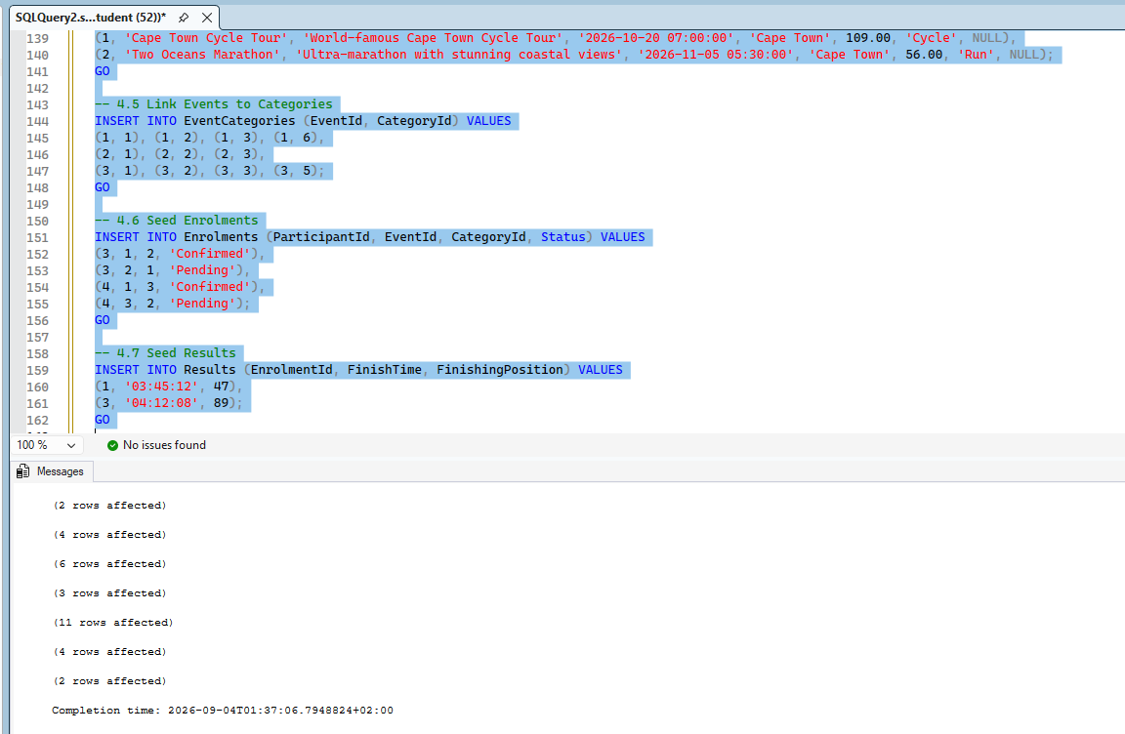
-- 5. VERIFICATION QUERIES
SELECT TABLE_NAME FROM INFORMATION_SCHEMA.TABLES WHERE TABLE_TYPE = 'BASE TABLE';
GO

SELECT * FROM Roles;
SELECT * FROM EventType;
SELECT * FROM Users;
SELECT * FROM Categories;
SELECT * FROM Events;
SELECT * FROM EventCategories;
SELECT * FROM Enrolments;
SELECT * FROM Results;
GO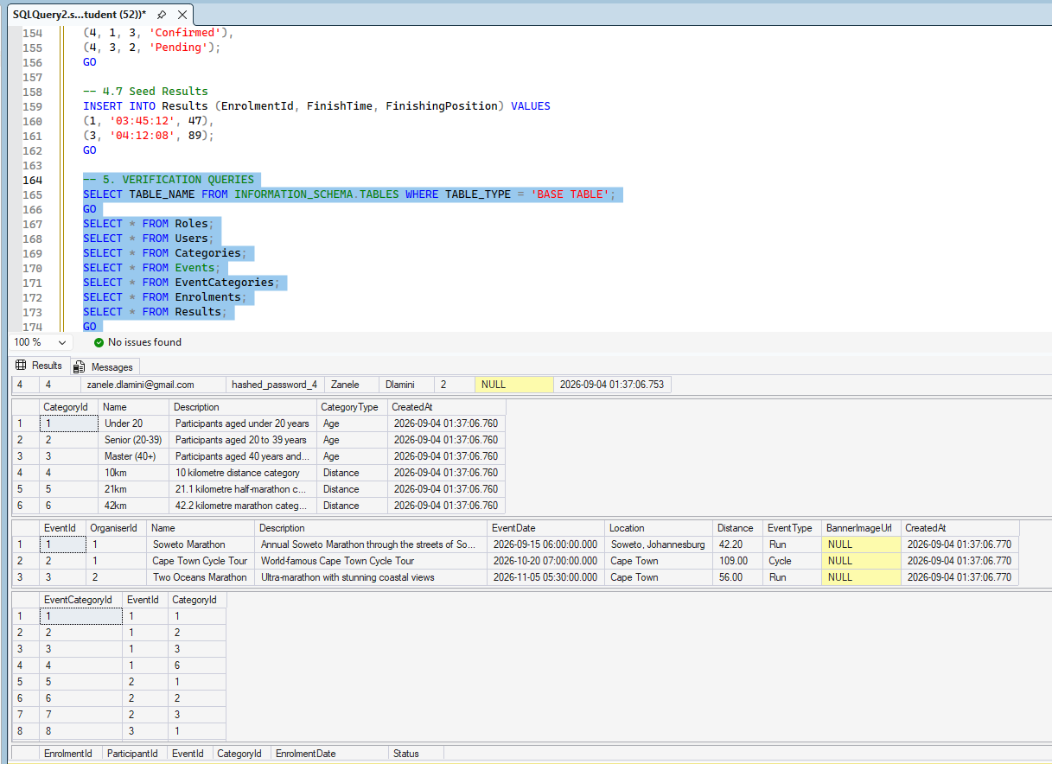

GitHub and Reference

https://github.com/ST10493031/RaceDayDB

Readme
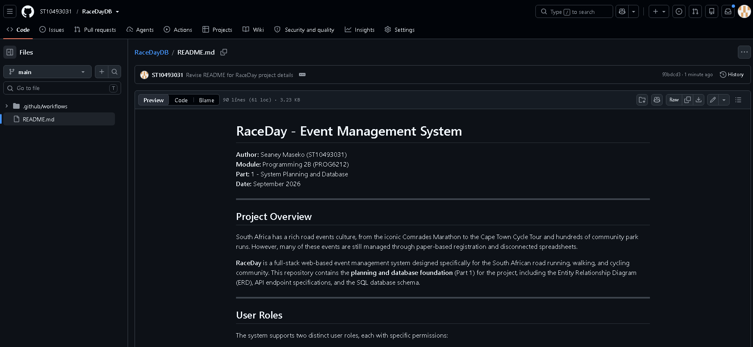 Scr

Video
link

References
3Wschool (2025). W3Schools.Com. [online] W3schools.com. Available at: https://www.w3schools.com/sql/ [Accessed 28 Aug. 2026].
Bootstrap (2023). Get started with Bootstrap. [online] getbootstrap.com. Available at: https://getbootstrap.com/docs/5.3/getting-started/introduction/ [Accessed 28 Aug. 2026].
chcomley (2026a). Azure Boards documentation. [online] Microsoft Learn. Available at: https://learn.microsoft.com/en-us/azure/devops/boards/ [Accessed 28 Aug. 2026].
chcomley (2026b). Azure DevOps documentation. [online] Microsoft Learn. Available at: https://learn.microsoft.com/en-us/azure/devops/ [Accessed 28 Aug. 2026].
dimitri-furman (2024). Monitoring and performance tuning — Azure SQL Database & Azure SQL Managed Instance. [online] Microsoft Learn. Available at: https://learn.microsoft.com/en-us/azure/azure-sql/database/monitor-tune-overview [Accessed 28 Aug. 2026].
IBM (2024). Think topics | IBM. [online] IBM.com. Available at: https://www.ibm.com/think/topics/agile [Accessed 28 Aug. 2026].
pauljewellmsft (2023). Get started with Azure Blob Storage and .NET — Azure Storage. [online] Microsoft Learn. Available at: https://learn.microsoft.com/en-us/azure/storage/blobs/storage-blob-dotnet-get-started [Accessed 3 Sept. 2026].
scrumguides (2025). Home | Scrum Guides. [online] scrumguides.org. Available at: https://scrumguides.org/ [Accessed 28 Aug. 2026].

